# New Product Commercialization: Common Mistakes

* 50% to 67% of firms fail in the commercialization process
  + Some, the product development process is flawed to start with
  + Others, the concept is poorly backed up by market research
  + Some others, it is the launch process and its execution that is at fault
    - If half of a factory’s output ended up as defects, you’d shut the place down
* Creating a team comprising members from different functions is probably the single most widely accepted concept in accelerating new product development
  + Able to solve potential problems early in the development cycle
  + Engender commitment more easily from all of the involved functions
    - Product champion or a project manager is highly recommended to have
  + This idea is to move project along its various phases as smoothly and efficiently as possible
* New Project Development Stages

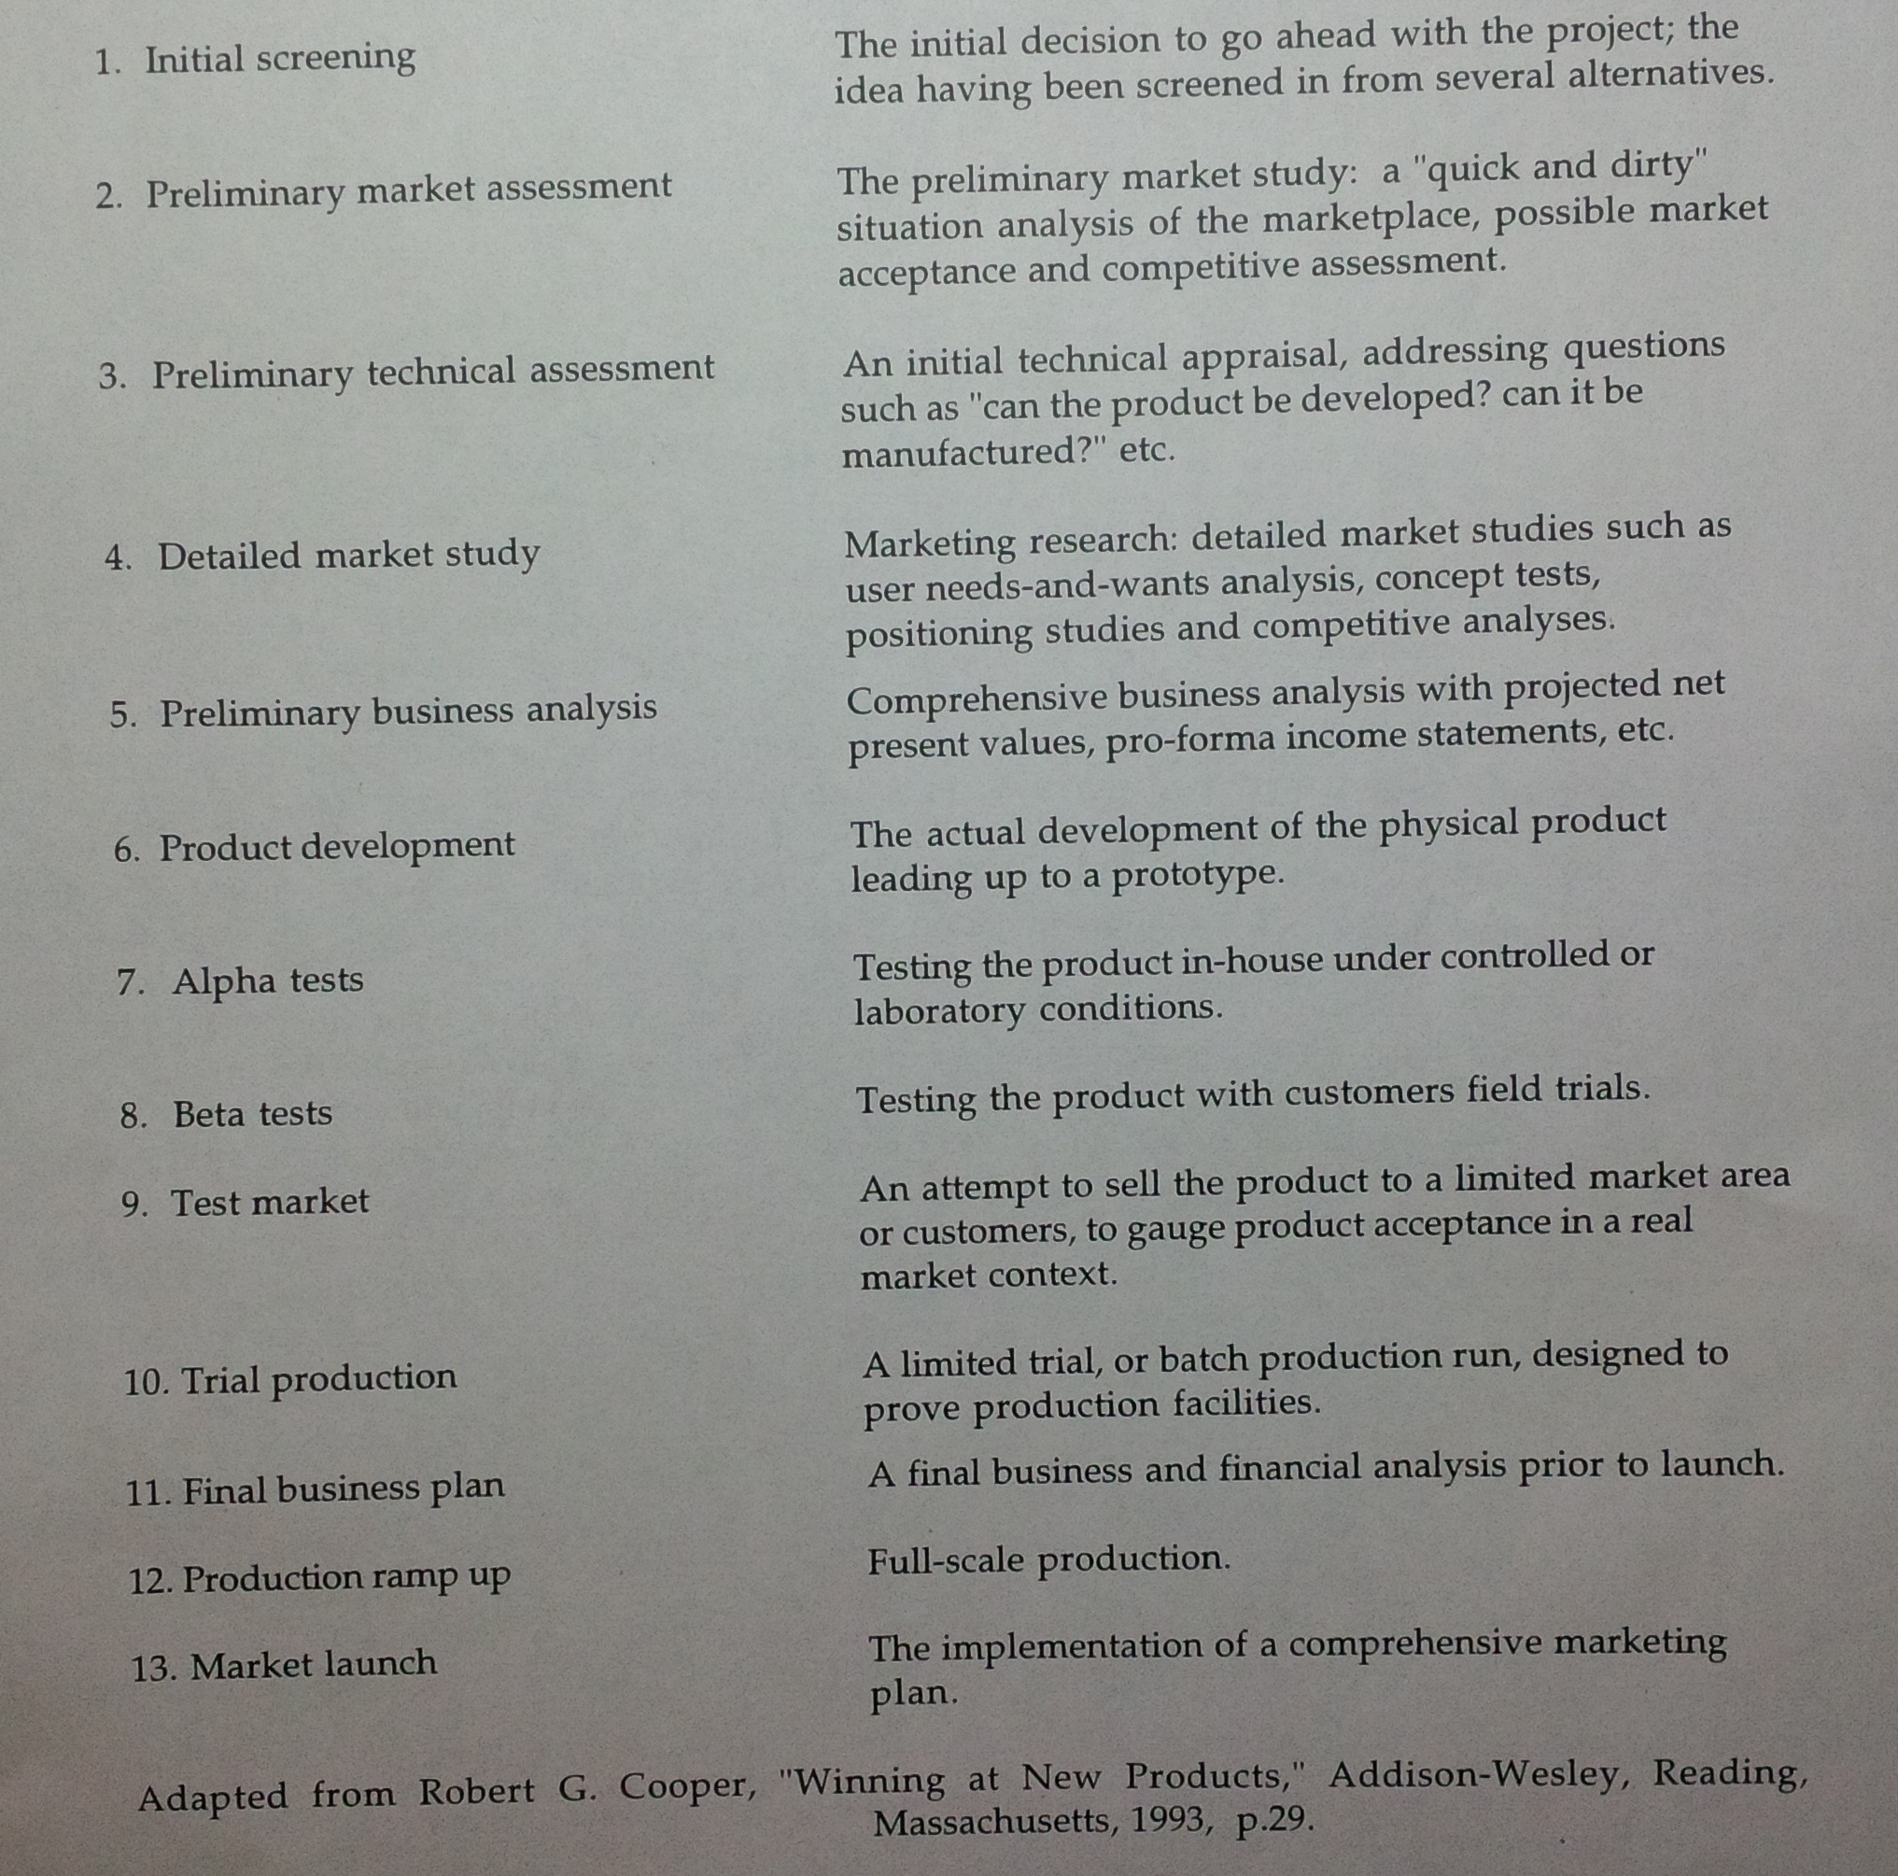

* Besides cross-functional team, a careful matching of the product development process to the type of product is required
* Krubasik
  + Different processes for different product context
  + Different levels of formal management sign-offs and check-points are appropriate for the different new product contexts
  + When development risks are high and opportunity costs are low
    - Product particularly advantageous accelerate product development
    - Such a process could boost project expense and jeopardize product performance and cost
    - Can implement Stage-gate system
      * Process involves staging the development over several gates
      * The project may proceed to the next gate only if it clears certain well-specified hurdles
  + When the development risk is low and opportunity costs are high
    - It is absolutely important to speed up the process
    - Several steps may have to run concurrently
  + The hardest process to manage is when the risks as well as the opportunity costs are high
    - While technology and cost considerations will necessitate a carefully staged process, market considerations demand speed

## Market mistakes

### A Framework

* A significant number fail precisely because supplier and customers do not see eye-to-eye on what the product is supposed to do
  + Disjunction between sellers and buyers
* The new product development process has to start with the voice of the customer, and in some cases, customers is seeking for incremental rather than radical innovation
* Framework
  + One axis is suppers’ perception of the new product
    - The other axis is customer perception
  + Two types of innovation
    - Breakthrough
      * Conceptual shifts that makes history
    - Incremental
      * Continuations of existing methods or practices

### Breakthrough and Incremental

* Breakthrough
  + Require intensive technology and/ or applications development
  + Customers are awed by the new product’s potential
  + It’s doubtful at this stage if a large number of customers really understand how the product usage characteristics will evolve and what usage patterns it will involve
  + It is important to have a technology vision at this stage in anticipation of market development
  + A projective vision and a keen sense of market anticipation is required in the development process
* Incremental
  + Customers will be able to play a major role in providing inputs for incremental products
  + Typically evolutionary development from their viewpoint
  + Customers usually will have a precise definition of what improvements they need in the product
  + Because of their experiences in making the previous generation products, manufactures will be able to fairly accurately estimate the technological and manufacturing changes required to serve the customers’ needs
  + Customers’ voices became the dominant impetus for new product design
  + Quality Function Deployment and Conjoint Analysis are useful
  + Incremental innovations are tended to meet narrow cost targets
  + The voice of the distribution channel has to be factored into the product lunch
* The new product introduction process must recognize and incorporate the market building and development activity
* Sales and manufacturing functions have a crucial role to play in developing and marketing incremental new products
  + Sales/distribution channel is often the one that is closest to the customer and in the best position to read customers’ feedback

### Mistake 1

* The most common mistake
* Utter lack of sensitivity to the differences in the management tasks required of incremental versus breakthrough projects
  + There is an overwhelming tendency to treat them all alike
* It is important to realize that cross-functional involvement is not a panacea to all new product development problem

### Mistake 2

* Not common as 1
* A tendency to assume that breakthrough projects equate with high profile activities needing resources and top management support, and that incremental projects are of less importance needing only a back-pocket support
  + This is not true
  + The resource allocation decision has to be based on the long-term financial attractiveness of the project
* Some breakthrough innovations may not have a large financial attractiveness of the project
* Do not confuse the nature of the product with potential pay-offs

### Shadowed new products

* The company’s portfolio is relatively minor in the short run
* These products are not the central thrust of a company’s R&D or sales strategy
  + These products discovered in the shadow of other important activity
* The reason of the fail of shadow product
  + These products do not generate the same sense of urgency or focus that accompanies “central” new products.
  + Commercialization usually follows organizational routines, and therein lies the crux of the problem

### Mistake 3

* Using existing organizational systems often means completely missing the boat on the real customer and his real needs
* Marketing is as much about creating and shaping customer needs as it is about serving well-identified customer requirements
* A frequent practice is to make a little, sell a little until the opportunity is crystal clear
  + Since the product is not central to the short-term financial well being, there is a tendency to look for some signs of success toward which further attention and resources may be directed

### Delusionary New Product

* These product represent the largest proportion of new product failure
  + These are innovations where the suppliers of the technology have grandiose visions for the product, but their customers often do not share the same euphoria
* Disconnect, unfortunately, comes because of an “inside-out” process rather than a lack of customer information
  + The data interpretation is faulty, not necessarily the data collection
    - To customer, they are viewing incremental innovation rather than a breakthrough innovation, and therefore the products was failed

### Mistake 4

* Such supplier misperceptions lead to faulty product positioning